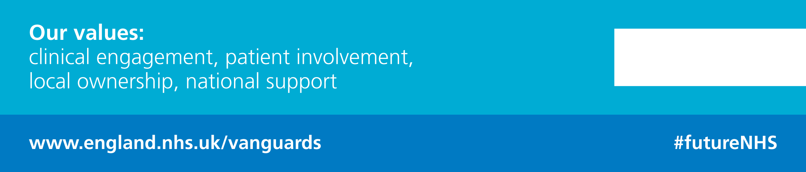
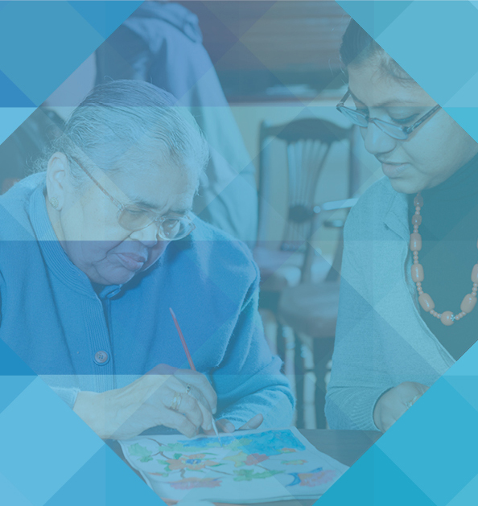

New care models

Airedale telehealth hub:
A guide to replicating
the model
August 2016

Contents
Contents 2
Introduction 3
About this guide 3
Airedale telehealth hub 4
Background 4
What it is 4
What it does 4
How it works 5
The telehealth hub in practise 6
What you need to get started 7
1. Technology 7
2. Skilled clinical practitioners 7
3. Electronic shared patient records 7
Challenges and learning 8
Engagement 8
Staff turnover – care homes 8
Technology 9
Recruitment 9
Will it work for you? 10
Technology 10
Shared records 10
Stakeholder relationships 10
Next steps 10
Find out more 10

Introduction
Nearly 400,000 older people live in care homes in the UK, nearly 20 per cent of whom are aged 85 and over. Most have complex health needs including multiple long-term conditions, significant disability and advanced frailty. Collectively they have high rates of both necessary and avoidable hospital admissions.
Care provided to this complex cohort of people is often fragmented. On top of this, day-to-day care services vary widely in standard, with high staff turnover and limited support from the wider health system.
NHS England guidance states that ‘Healthcare for care home residents should be an actively commissioned service, with clear specifications linked to quality outcomes and contractual obligations’. The British Geriatrics Society also recommends a multi-disciplinary approach to such commissioned services, including consistent access to specialist community nursing and a range of allied health professionals.
The Airedale and Partners enhanced health in care homes vanguard supports this approach. By redesigning the provision of healthcare around individuals, and better supporting the staff and individuals who care for them, it can offer older people better joined-up health, care and rehabilitation services.
The Airedale and Partners enhanced health in care homes vanguard is led by clinicians – nurses, doctors, and other health and social care professionals from a partnership of organisations including three hospitals, four CCGs, three councils, community healthcare, mental health, IT partners, numerous GP practices, GP federations and both local authority-run and independent care homes.
Its main focus is on the 7,687 residents living in 248 residential and nursing homes in Bradford, Airedale, Wharfedale, Craven and East Lancashire.

About this guide
This guide is intended for local service managers and clinical commissioning groups (CCGs) who are considering establishing a telehealth service in their local care homes. It serves to give a background to the service, as well as an explanation of how it works, what is required to set it up and what benefits it can provide. It also outlines potential problems and solutions.

Airedale telehealth hub

Background
The telehealth hub has been established since September 2011 and builds on work that Airedale Hospital had already been delivering for some years to support the prison population.
It was developed in response to audits demonstrating that care home residents requiring healthcare support experienced multiple GP visits, ED attendances or hospital admittances – many of which were avoidable.
It was felt that there was a better way to support them; one that would enhance their health and wellbeing, be more appropriate to meet their needs, and could be safely provided directly to them in their nursing or care home, enabled by technology.
The range of services delivered from the telehealth hub has diversified. In January 2016 the services moved to new premises and rebranded to the Airedale Digital Care Hub (the hub) to better reflect this growth.

What it is
Simply put, the hub is a way of using technology to remote-link nursing and care homes directly to healthcare professionals, round the clock.
A secure video link gives patients and staff in the homes immediate access to a ‘hub’ of senior nurses, based within the hospital, who can monitor people on screen and provide advice and support.
The hub is staffed by experienced nursing staff drawn from bands 6 and 7, with a wide range of acute and community experience including care of the elderly, emergency medicine, ICU, respiratory and cardiac care. These staff are supported by the skills and knowledge of the Airedale Trust’s wider medical and nursing consultants 24/7.
The technology is now in place in 217 care homes in the localities, and technology partners are helping to provide a real-time shared patient record which supports safer, quicker care and avoids duplication.

What it does
Having the technology installed allows staff in the care home to call the hub at any time of the day and night for assessment, advice and support as soon as they have concerns about the health and wellbeing of any of their residents. This offers peace of mind for staff, residents and their relatives.
Being triaged and monitored in their home setting rather than in hospital helps care home residents, including those with breathing problems, heart conditions and dementia, to remain active and independent by avoiding the significant stress that comes with an ED attendance or non-elective (NEL) hospital admission, which can take days to recover from. It also helps the care home avoid the staffing challenges that can arise when a resident has to be accompanied to ED.
Evidence has shown that use of the hub, with its single point of access to expert opinion, diagnosis and support, has reduced GP call-outs to care homes, as well as significantly reducing NEL admissions, ED attendances, length of stay and primary care visits.

How it works
Care home staff can call the hub any time of the day or night, whenever they need help and advice about the best care for a patient. The call is answered through the telemedicine video-link system by a trained clinical professional – usually a nurse – who will carry out a triage and assessment. The hub nurse has direct access to either a summary of the patient’s records or the full records, depending on the system being used (see ‘Technology’ for more detail) and will ask the caller for additional information as needed. They can then provide direct support and advice, or arrange for another service to respond as appropriate.

Who is involved
- The frontline clinical team consists of three or four specialist band 6 nurses, who are trained to monitor and assess care home residents via the video-link, providing support and advice, and arranging treatment when necessary. They work on seven-day rotas, including nights.
- One therapist and two social care staff screen referrals for intermediate care and provide support to the telemedicine nurses when required.
- A clinical team leader and a therapist lead the service developments in the hub.
- Specialist palliative care nurses are based in the hub at weekends, and access to specialist palliative care consultants is available by phone 24/7.
- The administrative support team compiles a directory of local services in conjunction with each CCG that contracts the service and keeps it up to date, allowing the clinical team to refer staff and care home residents to the appropriate service in that CCG locality.

A new service, called ‘complex care’, was launched in April 2016. The hub telemedicine nurses act as the out of hours contact for complex care patients, and a complex care team of three ANPs, a mental health nurse, a physiotherapist, three care navigators and a team leader is based in the hub. The team is clinically led by a GP and hospital consultant.

The telehealth hub in practise

Case study 1: Early intervention from telehealth nurses enables lifesaving treatment
A senior nurse in the telehealth hub received an urgent call from nursing home staff. An 86-year-old care home resident had suddenly collapsed, developed left-sided weakness and a facial droop, and become incoherent with slurred speech. He suffered from dementia but was normally alert, mobile and relatively well.
“I was able to see from his symptoms that it was highly probable he had suffered a stroke,” she explained.
The nurse called 999 for an ambulance and continued to monitor the patient and give support and advice to the care home staff via the video link until the paramedics arrived.
Hospital staff confirmed the patient had suffered an ischemic stroke but, thanks to the early diagnosis of his symptoms, he was a suitable candidate for thrombolysis treatment. This is known to greatly improve recovery after a stroke, but is only effective if administered within four and a half hours of the onset of stroke symptoms.
The resident was admitted to hospital for overnight monitoring and just four hours after the initial video link alert, he was sitting up in bed, drinking a cup of tea and asking if he could go home. He was discharged a few days later having made an almost complete recovery.
The prompt actions of the care home staff to access an acute clinical opinion resulted in an early diagnosis, which then resulted in the prompt instigation of potentially lifesaving treatment or even prevention of lifelong severe disability for this gentleman.

Case study 2: Telehealth hub provides reassurance to care home staff
Care home staff contacted the hub concerned about a resident who had severe chest pain, was short of breath and looked grey. The chest pain was of immediate concern, as this could be a symptom of a suspected heart attack, so the telehealth sister carried out a full ABCDE assessment via the video link and asked about the nature of the pain, which the patient described as “tummy ache”. The telehealth sister could see that the patient was rubbing their lower abdomen, and that their colour appeared quite normal. The patient was able to advise the shortness of breath was usual and that they had suffered from gallstones in the past.
What had initially appeared to be a suspected heart attack requiring emergency admission to A&E, turned out to be an episode of trapped wind, resolved with some warm peppermint tea and paracetamol. No other intervention was required and the patient recovered in the care home.

What you need to get started
There are three key elements that must be in place in order to set up a telehealth hub:
- Technology
- Skilled clinical practitioners
- Electronic shared patient records

Technology
Airedale has a joint venture partner – Involve – which supplies and installs a secure video link in each care home to the hub via a secure platform built to NHS standards. Each care home needs to have access to at least one laptop and a reliable internet connection (this is up to each care home to provide). The care homes also have access to a 24/7 helpline for technical support.
Cisco webcams, software and infrastructure are in use in Airedale but any HD1080p (hardware encoder) camera would be suitable. The 24/7 technical support helpline is provided by Involve.

Skilled clinical practitioners
Each telehealth hub needs highly skilled clinical practitioners to take the frontline calls; at Airedale there are band 6 and 7 nurses in this role. There are then a range of additional staff which could be a useful complement. At Airedale, therapists, social workers and specialist palliative care nurses support the clinical team and can also call on specialty doctor expertise at any time.

Electronic shared patient records
Access to shared patient records is essential to the effectiveness of the hub. How this is done locally will depend on which primary care system/s is/are used in your area.
Where each individual GP practice SystmOne unit is configured to share (with consent from the patient), the hub clinician requests access to the record at the time of the first consultation.
- If the patient agrees, the hub clinician will have full access to the SystmOne record.
- If the patient declines, the hub clinician will only have access to the information recorded on the national spine.
- If the patient lacks the capacity to consent, then the hub clinician and the carer or family member in the home will make a best-interest decision to override the consent process.
Where GP practices are not configured to share the patient record with other providers, each individual unit needs to be configured to share to the hub.
All consultations through the hub at Airedale are entered into SystmOne, and these notes can be seen by any healthcare professional with access to the patient’s SystmOne record. As it is not possible to write directly into other electronic patient records, a quick summary from SystmOne is sent electronically using NHS mail or DTS messaging to the patient’s GP to be uploaded into their record.
The hub team creates caseloads in SystmOne for each individual care home.

Options are currently being explored for viewing other electronic patient records, including EMIS. At present, a medical interoperability gateway (MIG) is being used to view EMIS for the Pendle locality of East Lancashire. This provides a limited view of the records, with no access to consultations and care plans. The Airedale Trust is now working with TPP to expedite their interface between SystmOne and EMIS, which will allow direct access to both EMIS and SystmOne records.

Challenges and learning

Engagement
The telehealth hub service can only be successful with the support of other organisations and stakeholders in the local area; engagement and good communication are key to its success. It is important to action a system-wide approach, with support from CCGs and stakeholders including local authorities, community service providers, ambulance services, GP practices and out-of-hours GP services, and voluntary sector organisations.

Engaging the care homes
Some care homes – particularly independent providers – may need to be persuaded that the hub would be beneficial for them. Airedale has addressed this challenge by specifically working with each care home to understand their challenges and show how the hub can help deal with them. For example, the hub can help staff deliver better care to their residents, make the CQC inspection regime easier and more transparent, and increase staff’s confidence and skills.
Providing care homes with comprehensive training is another effective way of engaging them. Face-to-face sessions have proven to be useful, both before and after the video link to the hub is installed, to give staff and residents the opportunity to see how the technology works and ask any questions. Printed materials such as a manual with usage instructions and contact details are also essential.
A third party, such as a trusted clinician (GP), can also help with engagement by recommending the service to care homes.

Engaging stakeholders
It is essential to have local stakeholders on board, as the hub often relies on referrals to local services. Airedale organised a significant amount of engagement activity with GPs, local authorities, community teams and others.
The engagement events consisted of presentations, question-and-answer sessions, articles for internal newsletters, and attendance at team and committee meetings, during which the service was explained and its benefits outlined. These include reducing the number of ED attendances, which so often translate into NEL admissions, as well as reducing inappropriate call-outs for GPs.

Staff turnover – care homes
Because many care homes have high staff turnover, it is essential to take a proactive approach to ensure that all staff working at the home are trained in the use of the equipment and understand the service. If a noticeable drop in calls from a care home occurs, it can be useful to contact the home to understand why; it may be that extra training is required.

Technology
There are three potential issues related to technology that will need to be considered:
- Expense: the initial set-up of the platform and infrastructure for the service is expensive, as a team of engineers is required to manage the installation and maintenance of the laptops and associated equipment used in the care homes. In most cases CCGs are funding the service. However, the vanguard receives extra funding and support from NCM, and has asked for help to get the technology in place.
- Connection: a reliable internet connection is essential for the service to work, but this is not available in some of the more rural areas. With the development in the coverage of 3G and 4G this is enabling some homes where internet access has been an issue to connect via 3G/4G. As coverage extends further this will provide an alternative to broadband for the homes.
- Shared records: Having access to shared electronic patient records is key, but different systems mean this is not always possible, leading to hub staff having to ask more questions during a call. There are some technological fixes for this however, and each area will need to work out their own requirements for their local systems.

Recruitment
The hub has become an attractive place to work. It is innovative and exciting, and allows staff to use their clinical expertise and develop new skills. For this reason, there are always high numbers of applicants when a vacancy arises.
However, it is important that the hub team is made up of highly skilled, senior staff who have the confidence and experience to make clinical assessments and judgements. They also need to have a thorough understanding of the hub process, as well as more general clinical processes. The care provided from the hub should be of the same quality as that provided to patients on a hospital ward.
As the staff who meet these criteria are often working in ward-based roles, there is a risk that recruiting them will leave gaps in frontline services.

Will it work for you?
Airedale believes that the telemedicine model is replicable. However, there are several factors that need to be taken into consideration.

Technology
Does the care home have a reliable internet connection (whether 4G or wi-fi)? Does it have laptops already in place or will they need to be provided by the technology company? Will it require the 24/7 helpdesk? Is the finance available within the CCG for the initial set-up?

Shared records
Is the GP supporting the care home residents willing to provide access to shared clinical records for the hub staff? If a system other than SystmOne is in use, the hub will need to find a way to link these.

Stakeholder relationships
Does the care home already have good working relationships with the key stakeholders in its area, or will it need to do a substantial amount of relationship-building and engagement activity first?

Next steps
A pilot project is underway which allows patients in Airedale to remain in their own homes and link to the telehealth hub via Skype. The pilot will include up to 65 patients, with recruitment currently underway. If the pilot proves successful, Skype will be rolled out more widely. Skype consumer is free to the end user providing they have their own device. However, there are limitations with Skype as this solution does not have call management functionality for managing work distribution across the team.
The telehealth hub has a great deal of potential beyond triage, advice and support. Airedale is currently exploring opportunities to use the system to deliver cost-effective training and development to care home staff via video-link.

Find out more
For more information about Airedale telehealth hub visit www.airedale-trust.nhs.uk, email marie.buchan@anhst.nhs.uk or rachel.binks@anhst.nhs.uk or call 01535 292767.

